WB-400 Factory Reset.
Turn machine ON. There should be no tire/rim on shaft.
Press the following sequence of buttons to do a Factory Code Reset.

- Press Home button
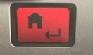
- Press DIS + button
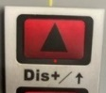
Your screen will now display “SET UP”
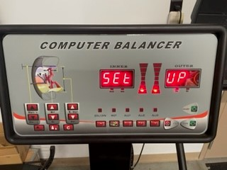
- Press Home 2 Times
Your screen will now display “POS” and “some number”
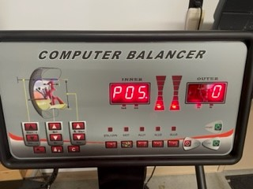
- Rotate shaft until “111” appears in the right window.
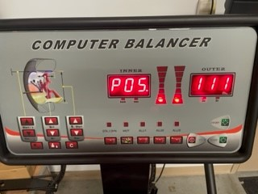
- Hit “C” button.
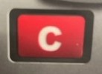

- Rotate shaft until “55” appears in the right window.
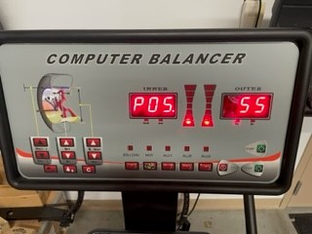
- Hit “C” button.

- Rotate shaft until “111” appears in the right window.
- Hit “C” button.
Your screen will now display “COD” and “Set”
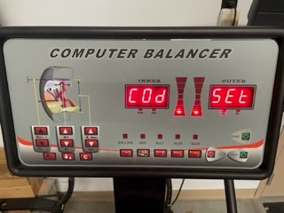
- Press Home key

Your screen will display “some number” on both sides
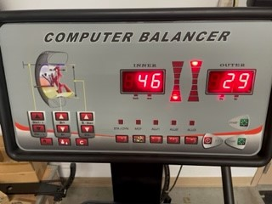

- Press DIS + repeatedly until “46” appears in the left window. Press home key.

Your screen will now display “B-A” and “some number”
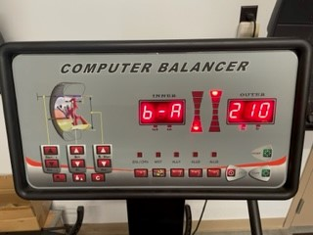

- Pull Distance Gauge out and put to Flange – note distance on distance gauge. The number on the right must match the number noted on the distance gauge.
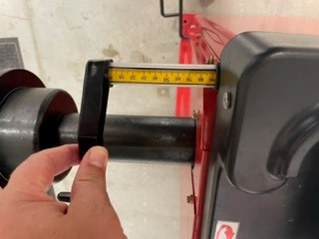

- Change the number on the right by pressing DIS + or DIS –. The number on the right must match the number noted on the distance gauge.
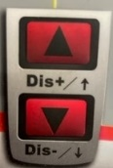

- Then press Home key.

Your screen will now display “EL1” “005”
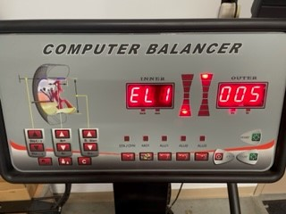

- Use DIS + or DIS – to change the number on the right to show 005 (in the unit of Gram) or 007 (in the unit of Ounce)

- Press Home key.
Your Screen will now display “Tur” “OFF”
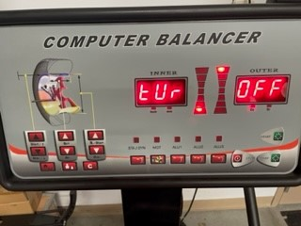

- Press home key again

You will now hear a series of Beeps

- Turn the machine off and back on.

YOU HAVE COMPLETED FACTORY RESET
------------------------------------------------------------------------------------

